**Question 1**

Internal controls are designed to safeguard assets, encourage employees to follow

company policies, promote operational efficiency, and ensure accurate accounting

records.

**Requirements**

1. Which objective do you think is most important?
2. Which objective do you think the internal controls must accomplish for the business

to survive? Give your reason.

**Question 2**

Answer the following questions about the controls in bank accounts:

**Requirements**

1. Which bank control protects against forgery?
2. Which bank control reports the activity in the customer’s account each period?
3. Which bank control confirms the amount of money put into the bank account?

**Question 3**

**Understanding the Sarbanes-Oxley Act and identifying internal control**

**strengths and weaknesses**

The following situations suggest a strength or a weakness in internal control.

1. Top managers delegate all internal control procedures to the accounting department.
2. Accounting department staff (or the bookkeeper) orders merchandise and approves invoices for payment.
3. Cash received over the counter is controlled by the salesclerk, who rings up the sale and places the cash in the register. The salesclerk matches the total recorded by the register to each day’s cash sales.
4. The employee who signs checks need not examine the payment packet because he is confident the amounts are correct.

**Requirements**

1. Define *internal control*.
2. The system of internal control must be tested by external auditors. What law or

rule requires this testing?

1. Identify each item in the list above as either a strength or a weakness in internal

control, and give your reason for each answer.

**Question 4**

Pendley Productions makes all sales on credit. Cash receipts arrive by mail. Larry

Chipello, the mailroom clerk, opens envelopes and separates the checks from the

accompanying remittance advices. Chipello forwards the checks to another employee,

who makes the daily bank deposit but has no access to the accounting records.

Chipello sends the remittance advices, which show cash received, to the accounting

department for entry in the accounts. Chipello’s only other duty is to grant sales

allowances to customers. (A *sales allowance* decreases the customer’s account receivable.)

When Chipello receives a customer check for $575 less a $45 allowance, he records the

sales allowance and forwards the document to the accounting

department.

**Requirements**

* 1. Identify the internal control weakness in this situation.
  2. Who should record sales allowances?
  3. What is the amount that should be shown in the ledger for cash receipts?

**Question 5**

Each of the following situations has an internal control weakness.

1. Jade Applications has decided that one way to cut costs in the upcoming year is to fire the external auditor. The business believes that the internal auditor should be able to efficiently monitor the company’s internal controls.
2. In an effort to minimize the amount of paperwork, Ross Homes has decided that it will not keep copies of customer invoices related to sales revenue. Ross believes that this effort will minimize the amount of data storage the company will have to pay for.
3. Elle Bee, a trusted employee for many years, has never taken a vacation. The owner believes that he’s lucky that she is so committed to her job.
4. The Medicine Chest Company keeps a small petty cash fund to handle small cash transactions. Because no one wants to volunteer to be the custodian, the business manager has decided that all employees should have access to the petty cash. She figures that as long as each employee fills out a petty cash ticket, then there are proper controls in place.
5. Due to the cost of maintaining the security cameras, Wings and More has decided that it will remove the cameras that monitor the cash register.
6. Bryan Miller, manager of Hardware Emporium, prides himself on hiring exceptionally skilled employees who need no training to do their jobs.

**Requirements**

**1.** Identify the missing internal control characteristics in each situation.

**2.** Identify the possible problem caused by each control weakness.

**3.** Propose a solution to each internal control problem.

**Question 6**

On September 1, Party Salad Dressings creates a petty cash fund with an imprest Balance of $600. During September, Michael Martell, the fund custodian, signs the Following petty cash tickets:

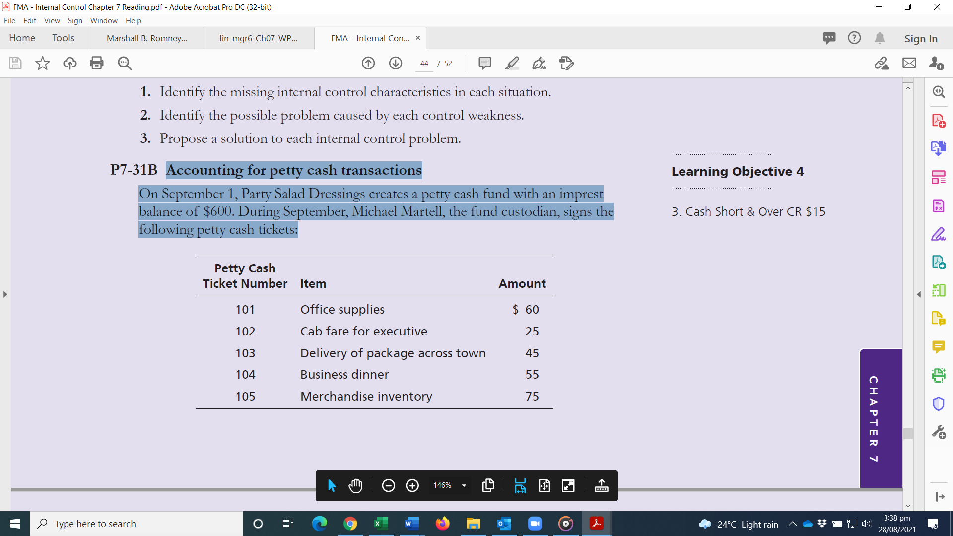

On September 30, prior to replenishment, the fund contains these tickets plus cash

of $355. The accounts affected by petty cash payments are Office Supplies, Travel

Expense, Delivery Expense, Entertainment Expense, and Merchandise Inventory.

**Requirements**

1. Explain the characteristics and the internal control features of an imprest fund.
2. On September 30, how much cash should the petty cash fund hold before it is replenished?

**Question 7**

Tralor Corporation manufactures and sells several different lines of small electric components. Its internal audit department completed an audit of its expenditure processes. Part of the audit involved a review of the internal accounting controls for payables, including the controls over the authorization of transactions, accounting for transactions, and the protection of assets. The auditors noted the following items:

* 1. Routine purchases are initiated by inventory control notifying the purchasing department of the need to buy goods. The purchasing department fills out a prenumbered purchase order and gets it approved by the purchasing manager. The original of the five-part purchase order goes to the vendor. The other four copies are for purchasing, the user department, receiving for use as a receiving report, and accounts payable.
  2. For efficiency and effectiveness, purchases of specialized goods and services are negotiated directly between the user department and the vendor. Company procedures require that the user department and the purchasing department approve invoices for any specialized goods and services before making payment.
  3. Accounts payable maintains a list of employees who have purchase order approval authority. The list was updated two years ago and is seldom used by accounts payable clerks.
  4. Prenumbered vendor invoices are recorded in an invoice register that indicates the receipt date, whether it is a special order, when a special order is sent to the requesting department for approval, and when it is returned. A review of the register indicated that there were seven open invoices for special purchases, which had been forwarded to operating departments for approval over 30 days previously and had not yet been returned.
  5. Prior to making entries in accounting records, the accounts payable clerk checks the mathematical accuracy of the transaction, makes sure that all transactions are properly documented (the purchase order matches the signed receiving report and the vendor’s invoice), and obtains departmental approval for special purchase invoices.
  6. All approved invoices are filed alphabetically. Invoices are paid on the 5th and 20th of each month, and all cash discounts are taken regardless of the terms.
  7. The treasurer signs the checks and cancels the supporting documents. An original document is required for a payment to be processed.
  8. Prenumbered blank checks are kept in a locked safe accessible only to the cash disbursements department. Other documents and records maintained by the accounts payable section are readily accessible to all persons assigned to the section and to others in the accounting function.

RRReview the eight items listed and decide whether they represent an internal control strength or weakness

1. For each internal control strength you identified, explain how the procedure helps achieve good authorization, accounting, or asset protection control.
2. For each internal control weakness you identified, explain why it is a weakness and recommend a way to correct the weakness

**Question 8**

Equestrian Co manufactures smartphones and tablets. Its main customers are retailers who then sell to the general public. The company’s manufacturing is spread across five sites and goods are stored in its nine warehouses located across the country. You are an audit supervisor of Baseball & Co and in preparation for the forthcoming audit for the year ending 30 June 20X7, you are reviewing the following notes your audit manager has provided you with in relation to the company’s internal controls. Equestrian Co has a small internal audit (IA) department. During the year, IA started a programme of physically verifying the company’s assets and comparing the results to the non-current assets register, as this type of reconciliation had not occurred for some time. To date only 15% of assets have had their existence confirmed as IA has experienced significant staff shortages and several members of the current IA team are new to Equestrian Co. During the year, Equestrian Co conducted an extensive reorganization of its manufacturing process to improve efficiency. Due to the significant number of employee changes required, the human resources department (HR) has been very busy and to ease their workload during this period, the payroll department has assisted by setting up any new employees who have joined the company. In January 20X7, the wage rate paid to employees was increased by the HR director and he notified payroll by emailing the payroll supervisor. A new sales ledger system was introduced in May 20X6 and will continue to be run in parallel with the old system until IA has completed its checks between the two systems. New customers obtained by the sales team are required to undergo a full credit check; on the basis of this, a credit limit is proposed by sales staff and approved by the sales director and these credit limits remain static in the sales system. Monthly perpetual inventory counts are undertaken at each of the nine warehouses, as a full year-end inventory count is too disruptive for the company. High value items are stored in a secure area in each warehouse. Access is via a four digit code, which for convenience is the same across all sites. Due to the company’s reorganization programme, some of the monthly inventory counts were not performed. Bank reconciliations are undertaken monthly by an accounts clerk and details of all reconciling items are included. Where the sum of the reconciling items is significant, the reconciliation is sent to the financial controller for review. In order to maximize cash balances, the finance director approves all purchase invoices for payment 75 days after receipt of the invoice.

**Required:**

(a) Identify and explain EIGHT deficiencies in Equestrian Co’s internal controls and provide a recommendation to address each of these deficiencies.