## Steps to access SharePoint:

A user will receive an email notification, stating the SharePoint site they have been added to.

Once your click on the SharePoint site link.

A browser will redirect you to the login page.

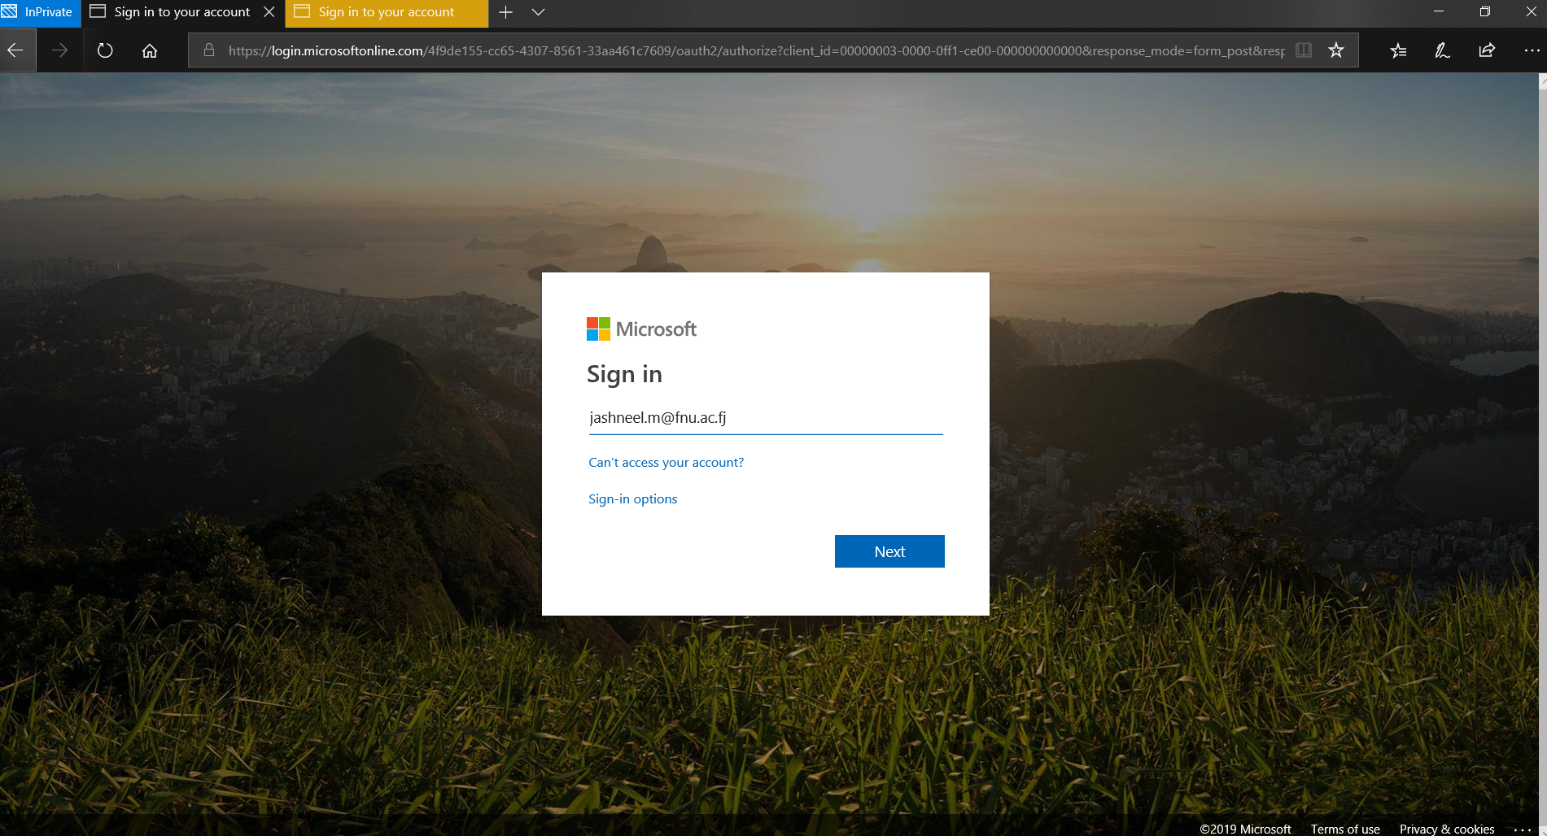

* Login using the same account. The account where the link was sent.
* Enter your username and password to login.

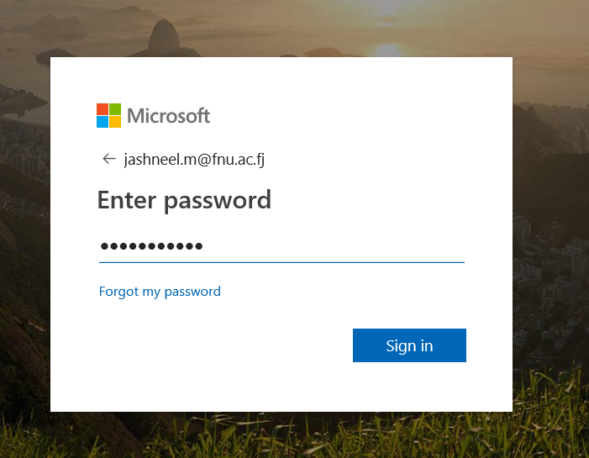

* After logging in successfully the browser will take you to the SharePoint site. As shown below:

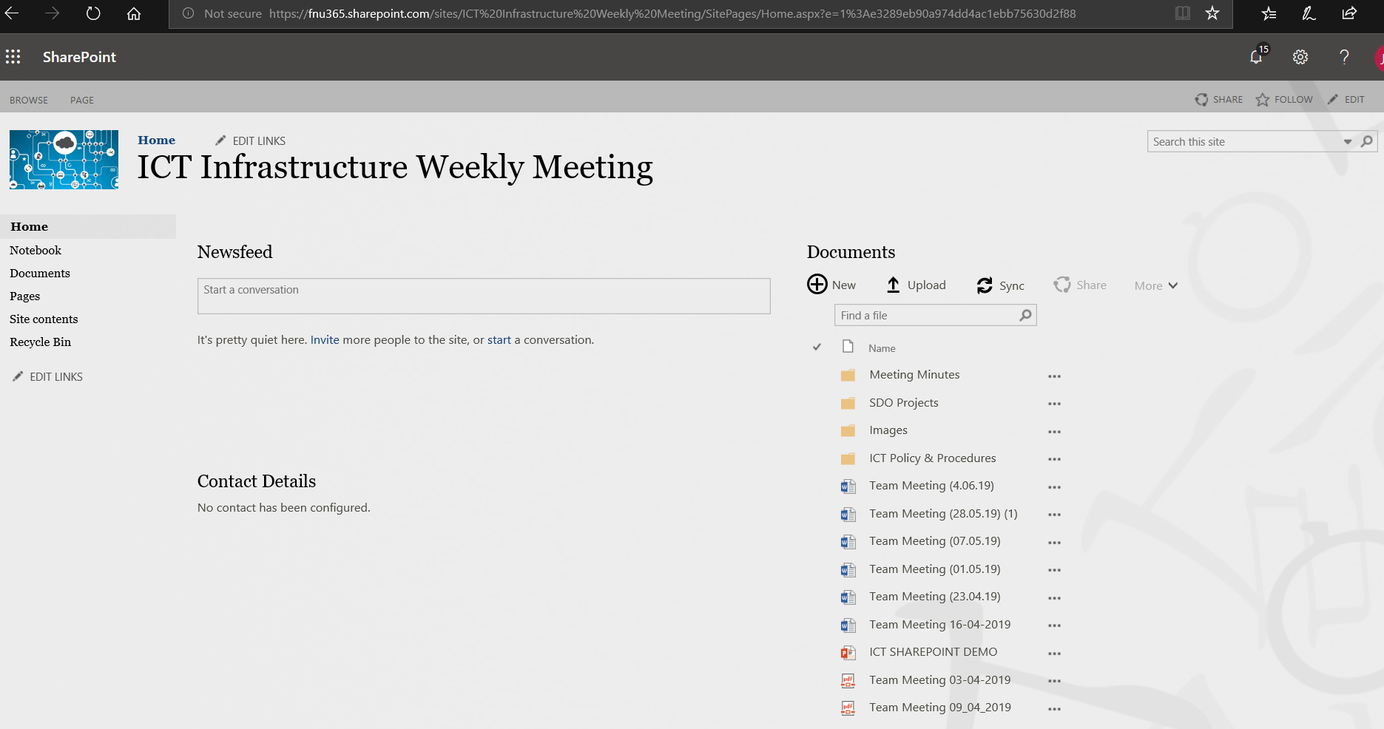

* It is very important to click on the **follow** button on the SharePoint site.

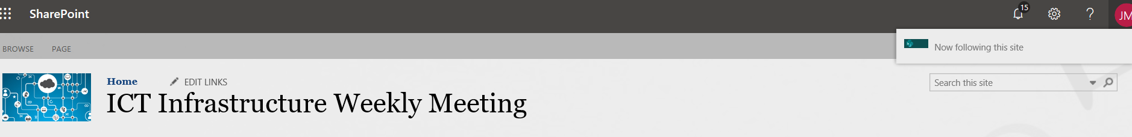

By clicking follow the share folder for the SharePoint site will be then listed under your shared drives in One Drive web portal as shown below.

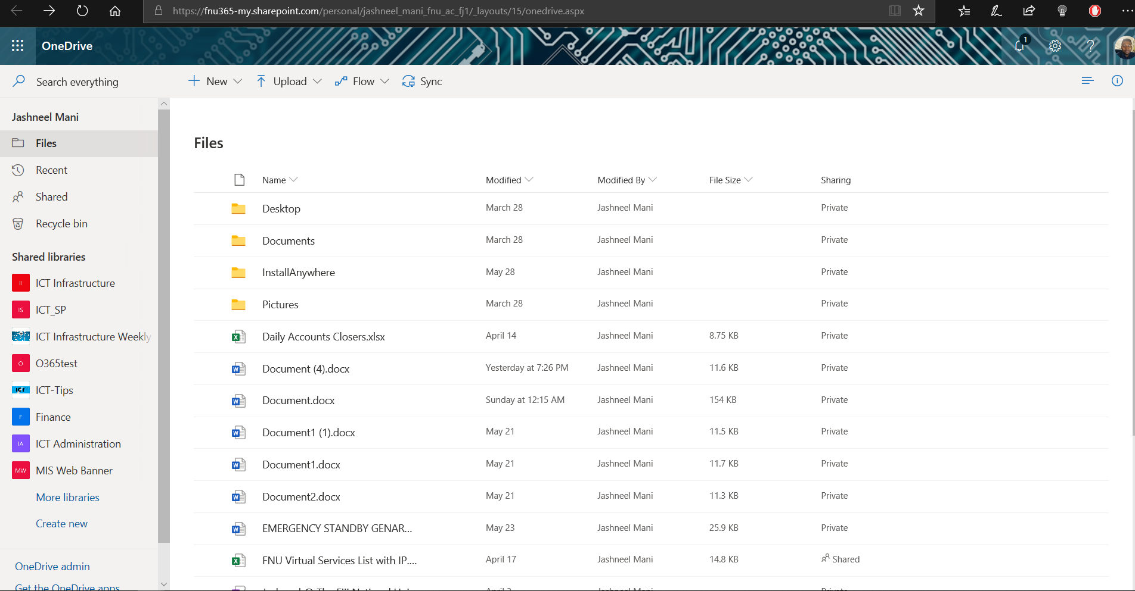

## Share Site management for Site owners.

Here's how to change logo, title, and other settings for SharePoint Online team or communication sites.

**Important:** To make changes to the logo, title, description, and other settings you must have owner or designer permissions on the SharePoint site. For more info, see [managing site permissions](https://support.office.com/en-ie/article/manage-your-sharepoint-site-settings-8376034d-d0c7-446e-9178-6ab51c58df42#__bkmkmngsitepermissions).

## Change the logo for your SharePoint team or communication site.

SharePoint Online team sites that are connected to an Office 365 group use the same logo as the Office 365 group to which they are connected. When you change the logo for your SharePoint group-connected team site, the logo for the corresponding Office 365 group will change also. The process for changing the logo for a SharePoint Online communication sites or a SharePoint Online team sites that's not connected to an Office 365 group is the same. In this case, only the site logo changes.

1. Go to your SharePoint team or communication site.
2. In the top right corner, click **Settings** Settings iconand then click **Site information**.

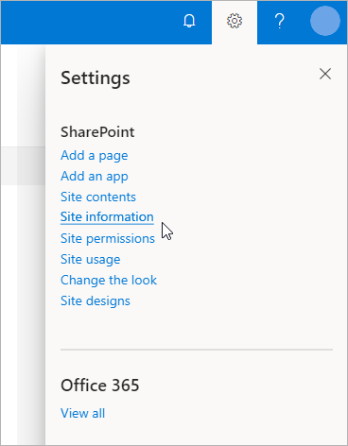

1. Under the site logo, click **Change**.

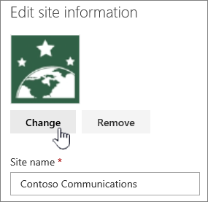

FNU TEST

1. Browse and select the new logo, click **Open**,

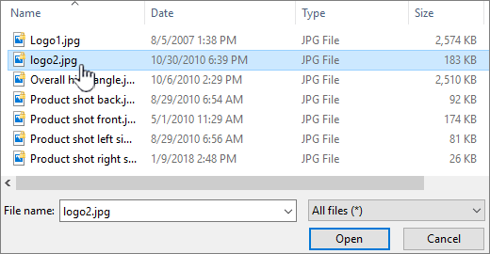

and then click **Save**.

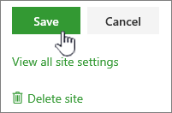

* Change the name, description, privacy level, and site classification.

**Important:** To change these settings you must have owner or designer permissions on the SharePoint site. For more info, see [managing site permissions](https://support.office.com/en-ie/article/manage-your-sharepoint-site-settings-8376034d-d0c7-446e-9178-6ab51c58df42#__bkmkmngsitepermissions).

These settings are only on a group-connected team site.

1. Go to your SharePoint team site.
2. In the top right corner, click **Settings** Settings icon and then click **Site information**.



1. Change the fields you want:
   * Team site name (required)
   * Description (optional)
   * Privacy settings (optional): Public means everyone in your organization can see the content and become a member. Private means that membership requires approval by a site owner, and only members can view the content. This does not appear on a communication site.
   * Team site classification (optional): Used to classify a site using values such as internal, confidential, high business impact, low business impact, etc. These values can pertain to sensitivity of information or to the lifecycle of information. They are determined and created by your administrator. For more information, see [Manage site creation in SharePoint Online](https://docs.microsoft.com/sharepoint/manage-site-creation). This option may not be available on your site.

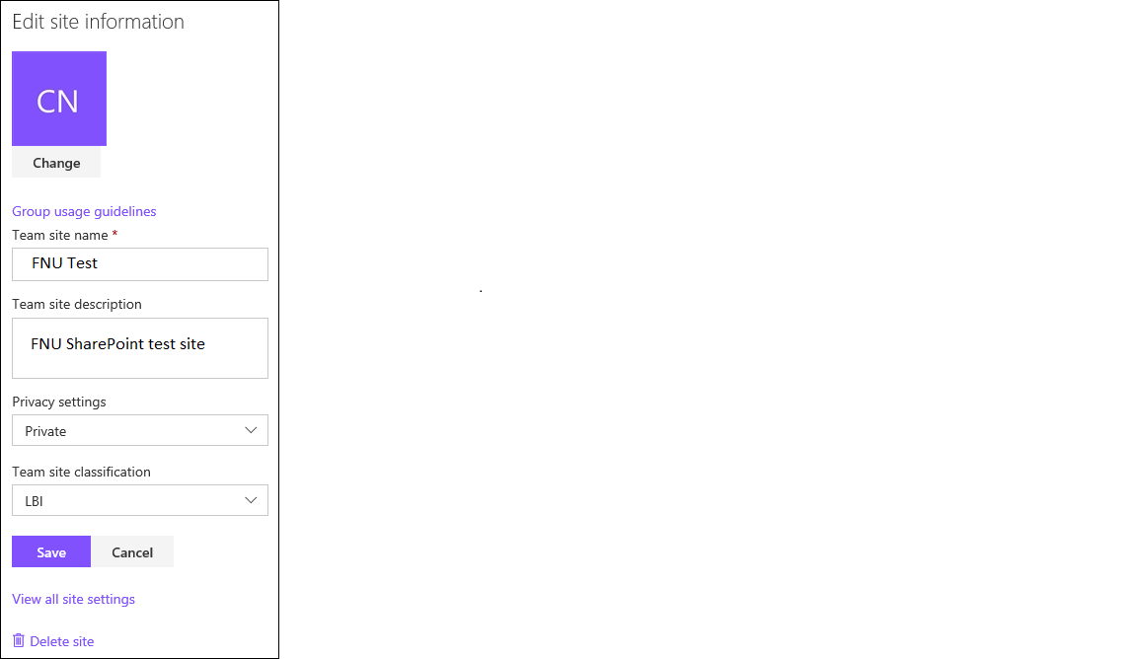

These are the most common settings for sites. To change other settings and options for the site, click **View all site settings**. This brings up the classic SharePoint **Site Settings** page.

## Apply a site design

Select a site design to apply a consistent set of actions or configurations such as setting a theme, adding links to the site navigation, or creating a list with a specific set of columns and settings to a site.

* Go to your SharePoint team site.
* In the top right corner, click **Settings** Settings icon> **Site designs**.
* Select the design you want to apply and click **Apply to site**.

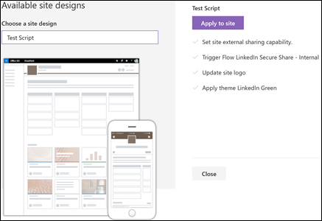

## Manage site permissions

Site permission levels are based on SharePoint permission groups. Members of a SharePoint permission group can either visit the site without editing it (Site visitors), edit the site (Site members), or have full control of the site (Site owners).

**Important:** To change these settings you must have owner permissions on the SharePoint site.

1. Go to your SharePoint team site.
2. In the top right corner, click **Settings** Settings icon.
3. Click **Site permissions**.

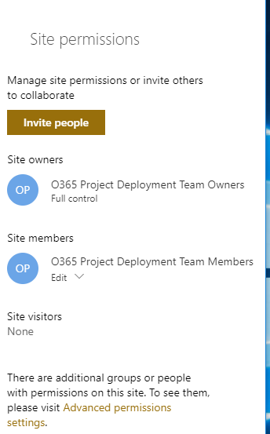

## Invite people to your SharePoint team site

To give people access to your site, you can either add members to the Office 365 group associated with the site or you can share the site with others without adding them to an Office 365 group. For more on site permissions, see [Understanding permission levels in SharePoint](https://docs.microsoft.com/en-us/sharepoint/understanding-permission-levels).

Group owners will be able to add members to their SharePoint sites, also approve and access request.

Steps:

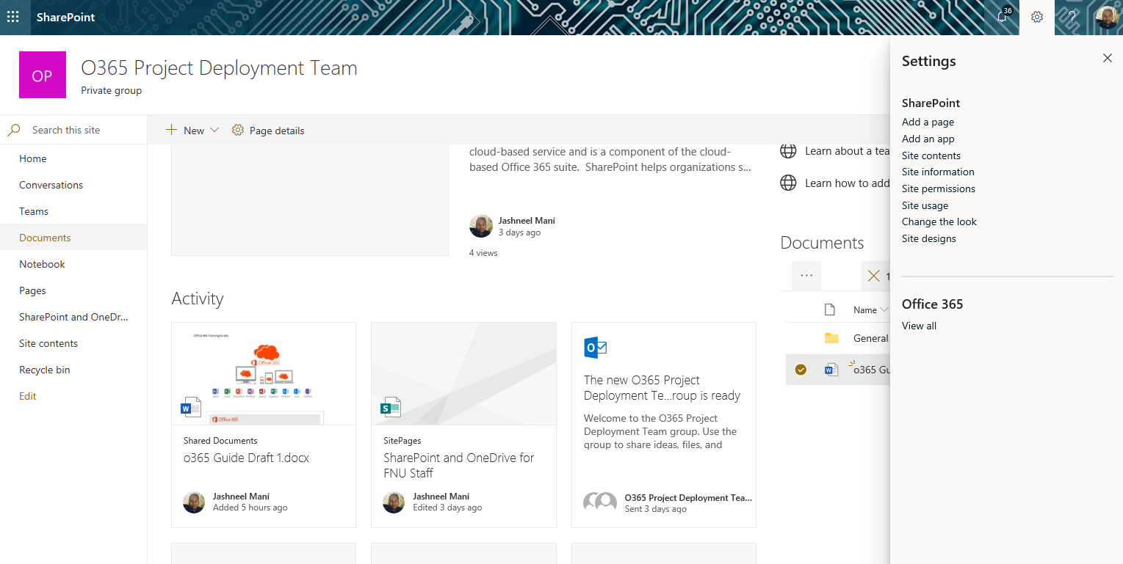

1. To add members, click on the setting icon on the top right corner.
2. Click on site permissions.

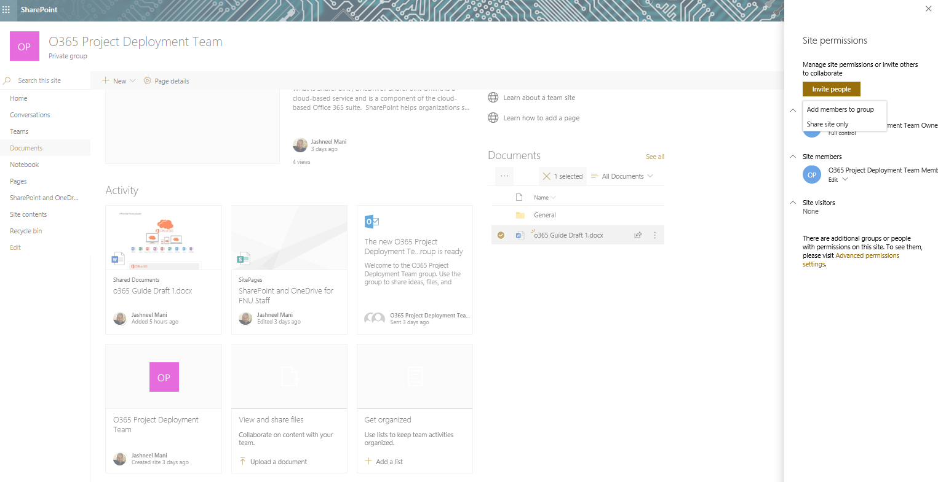

1. Once site permission tab is open. Click on invite people.

In **SharePoint Online**, to give people access to your site, click **Invite people** and choose one of the following:

* **Add Members to Group**: to add members to the Office 365 group associated with your site. This is the preferred method. Click **Add members**, enter a name or email address, and click **Save**. Members added to the Office 365 group are added to the SharePoint Site members permission group by default and can edit the site. They also have full access to the Office 365 group resources such as group conversations, calendar, etc.
* **Share Site Only:** to share the site with others without adding them to the Office 365 group associated with the site. Enter a name or email address, click the down arrow to select the SharePoint permission level, and then click **Add**. Sharing the site gives users access to the site, but they won't have access to the Office 365 group resources such as group conversations, calendar, etc.

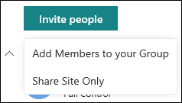

In **SharePoint 365**, click **Share site**. In the Share site panel, enter the name of users or groups to share the site to.

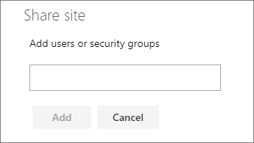

## Change site permissions

To change the permission level for an individual or group, click the down arrow next to the SharePoint permission level for that person or group and select **Full Control** to add them to the Site owners’ group, or **Read** to add them to the Site visitors’ group.

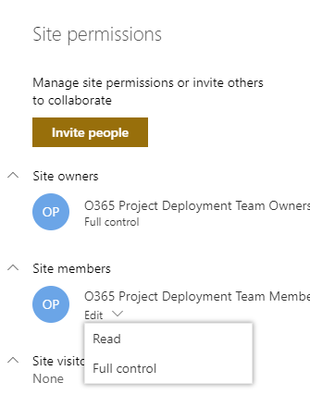

**Note:** To view all members of the Office 365 group associated with your site and their SharePoint permission levels, click **members** at the top right corner of your site.

**Remove site permissions**

In SharePoint Online, to remove someone who isn't a member of the Office 365 group associated with your site, click the down arrow next to the SharePoint permission level for that group and select **Remove**.

**Note:** The **Remove** option is only available for individuals or groups that aren't part of the Office 365 group.

To remove someone from the Office 365 group associated with your site, click **members** at the top right corner of the site, click the down arrow next to the permission level for that member, and click **Remove from group**.

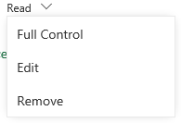

**Advanced permission settings**

If you are a site owner, you will see a link for **Advanced permission settings** where you can configure additional SharePoint permission settings. For more information, see [Understanding permission levels in SharePoint](https://support.office.com/en-ie/article/understanding-permission-levels-in-sharepoint-87ecbb0e-6550-491a-8826-c075e4859848).

## Users Requesting access to SharePoint sites

* If staffs visit the shared site via URL and do not have permission, they can request access to the department SharePoint sties via the request page as shown below.

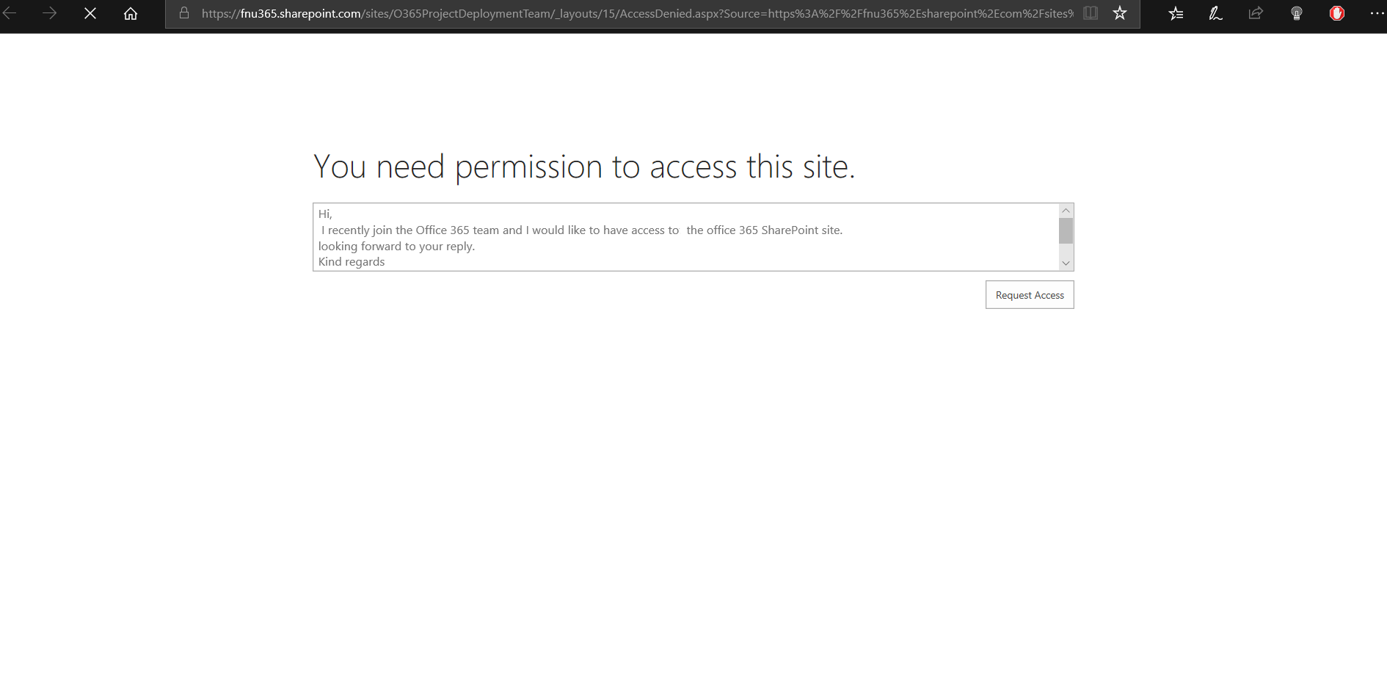

* The requester will fill in the request and an email will be sent to the group owners. Then the group owner will decide on what type of permission to assign to the requestor.
* The group owners will receive the below email notification and they can decide on the approval.

