**Office 365 & SharePoint**

Steps: Login to Office 365

1. Click on the Link to login: <https://www.office.com/>

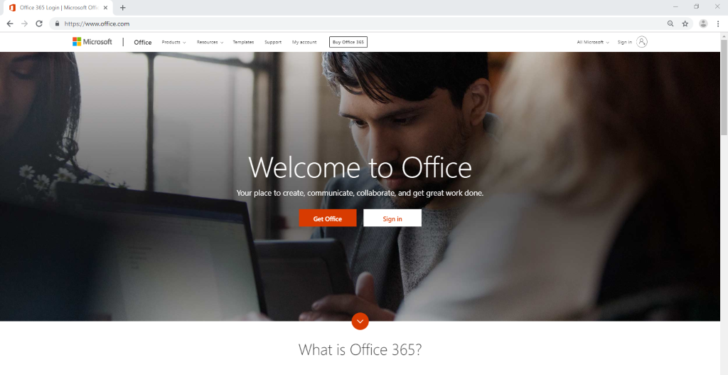

Click on **Sign In**

1. Enter your FNU Domain account: [username@fnu.ac.fj](mailto:username@fnu.ac.fj) (example: [jashneel.mani@fnu.ac.fj](mailto:jashneel.mani@fnu.ac.fj))

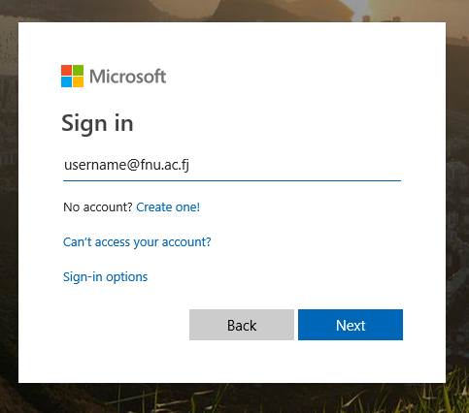

Once Email is entered, click on **Next**

1. Enter your FNU Domain **password**.

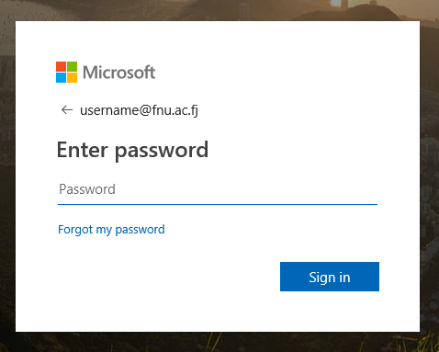

Once entered then click on **Sign In.**

1. Click **Yes** if the device you are using is assigned you (login details will be saved).

Or click on **No**

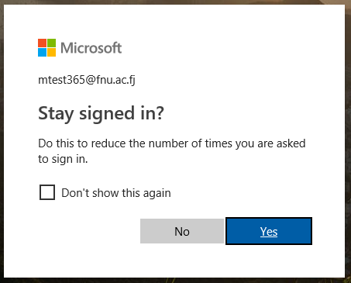

1. Once the sign in is successful. Below is the Landing page (Dashboard) of Microsoft Office 365.Here users will be able to access all the apps provided with their Office 365 account.

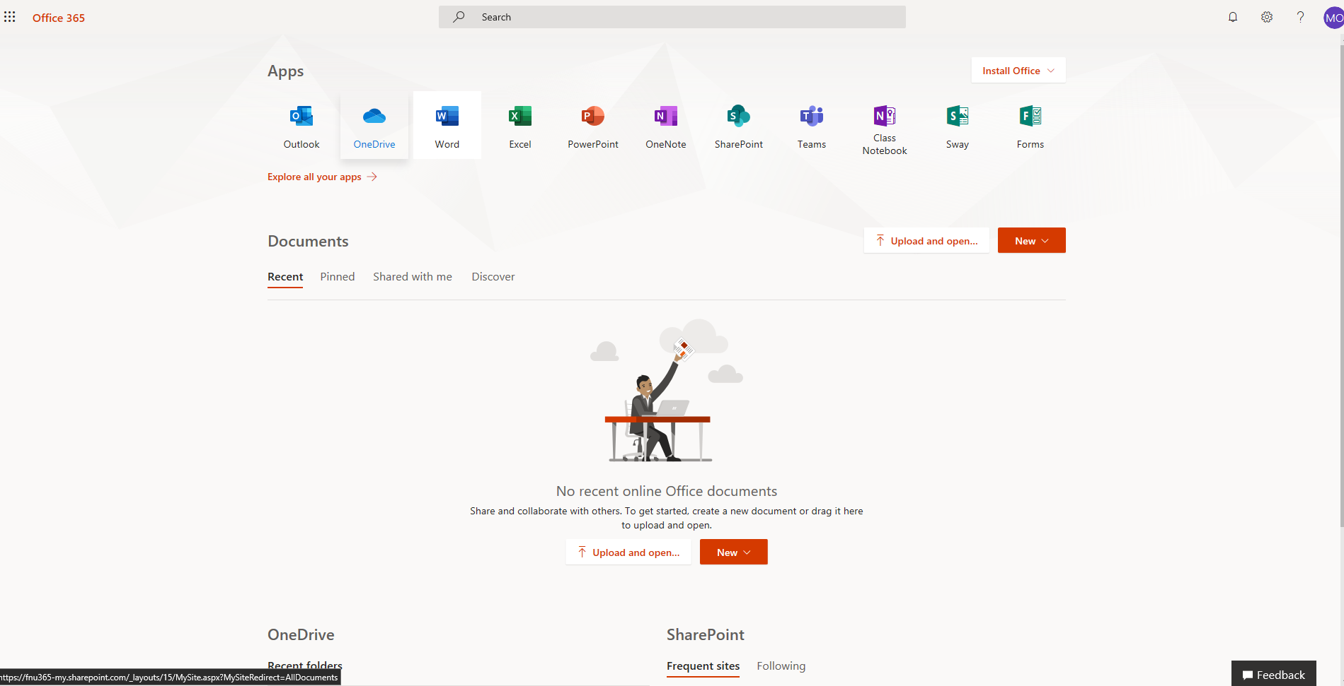

## 

1. Go to SharePoint front page or document directory Dashboard
2. Click upload
3. Dialog Box will open, select file or folder
4. Choose the file you would like to upload and click open.

Alternatively, if your file is already open, you can simply drag the file you would like to upload, into the files space.

## 

## Sharing files/folder using one drive

1. Select the file or folder you want to share, and then right click to select **Share**.
2. Enter the names of the people or groups you want to share the file or folder with. You also have the option to add a message.

Step 2

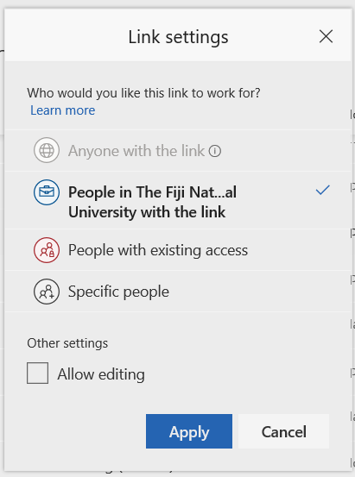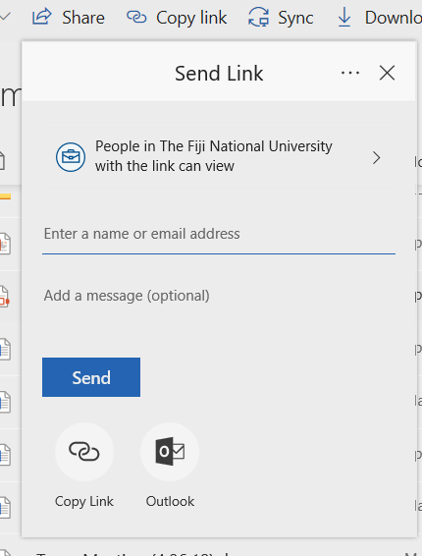

**Optional**: Click the **dropdown** list to change the type of link. The **Details** pane opens, where you can change who can access the link and whether people can edit the item you’re sharing.

Options for **Who would you like this link to work for** (options vary based on admin settings):

* + **Anyone** gives access to anyone who receives this link, whether they receive it directly from you or forwarded by someone else. This may include people outside of your organization.
  + **People in <The Fiji National University>** gives anyone in your organization who has the link, can have access to the file, whether they receive it directly from you or forwarded by someone else.
  + **People with existing access** can be used by people who already have access to the document or folder. It does not change the permissions on the item. Use this if you just want to send a link to somebody who already has access.
  + **Specific people** give access only to the people you specify, although other people may already have access. If people forward the sharing invitation, only people who already have access to the item will be able to use the link.

**Note**: By default, **allow editing** is turned off. If you want people to edit your files, check the check box.

When you're done, click **Apply**.

1. When you’re ready to send the link, click **Send**.