Chapter 10 - Page 415 of textbook
Behavioral Implications of Airline Depreciation
Accounting Policy Choices

- Assume that at least some rewards for the management team (and, hence, also other
employees) are based on performance measured in terms of accounting income and
returns on net assets. Also assume that all of these airlines are growing; that is, they
are adding to their fleet size.
What are the behavioral implications of each of the three depreciation-related accounting policy choices: (1) depreciation patterns (i.e., straight-line vs. accelerated); (2) estimated useful lives; and (3) residual values? Consider, at a minimum, the effects of each of these choices on decisions regarding:
- Replacements of aircraft in service;
- Pricing, assuming that prices are at least somewhat dependent on costs;
- Evaluations of routes or lines of business;
- Evaluations of managers, assuming that negotiated budgets provide the primary standards of performance.

- Assume that in a particular US airline company there is a conflict between the
benefits of conservatism vs. liberalism in depreciation accounting. That is, for this
company conservatism in depreciation accounting is greatly preferred for financial
reporting purposes (for whatever reason) but for internal purposes the company
would be better off if the policies were more liberal, or vice versa. Would you
recommend to the managers of this company that they adopt a third set of books?
That is, should they maintain one set of books for financial accounting purposes,
another set for tax purposes, and a third set for the purposes of running the
business?
- If the managers of a particular airline do not want to maintain a third set of books, should they tend to be conservative or liberal in their aircraft depreciation accounting? Explain.

Chapter 10 - Page 417 of textbook
Las Ferreterías de México, S.A. de C.V.

- Evaluate the proposed bonus plan that Mr. Gonzalez is considering.
- How, if at all, would you modify the proposed plan?

Other Questions
- List and briefly discuss the two limitations of financial performance measures.

- The following is divisional information for Kingfisher Enterprises:
 | East Division | West Division
Operating income | $250,000 | $200,000
Net sales | 2,225,000 | 1,575,000
Total assets at Jan. 1 | 1,500,000 | 840,000
Total assets at Dec .31 | 1,200,000 | 1,000,000

The target rate of return is 12% for the East Division and is 10% for the West Division.
Compute residual income for each division.

- The following is divisional information for Randolph Enterprises:
 | East Division | West Division
Operating income | $250,000 | $200,000
Net sales | 2,225,000 | 1,575,000
Total assets at Jan. 1 | 1,500,000 | 840,000
Total assets at Dec .31 | 1,200,000 | 1,000,000

The target rate of return is 12% for the East Division and is 10% for the West Division.
Compute the return on investment for each division. (Round to one decimal place.)

Question 4
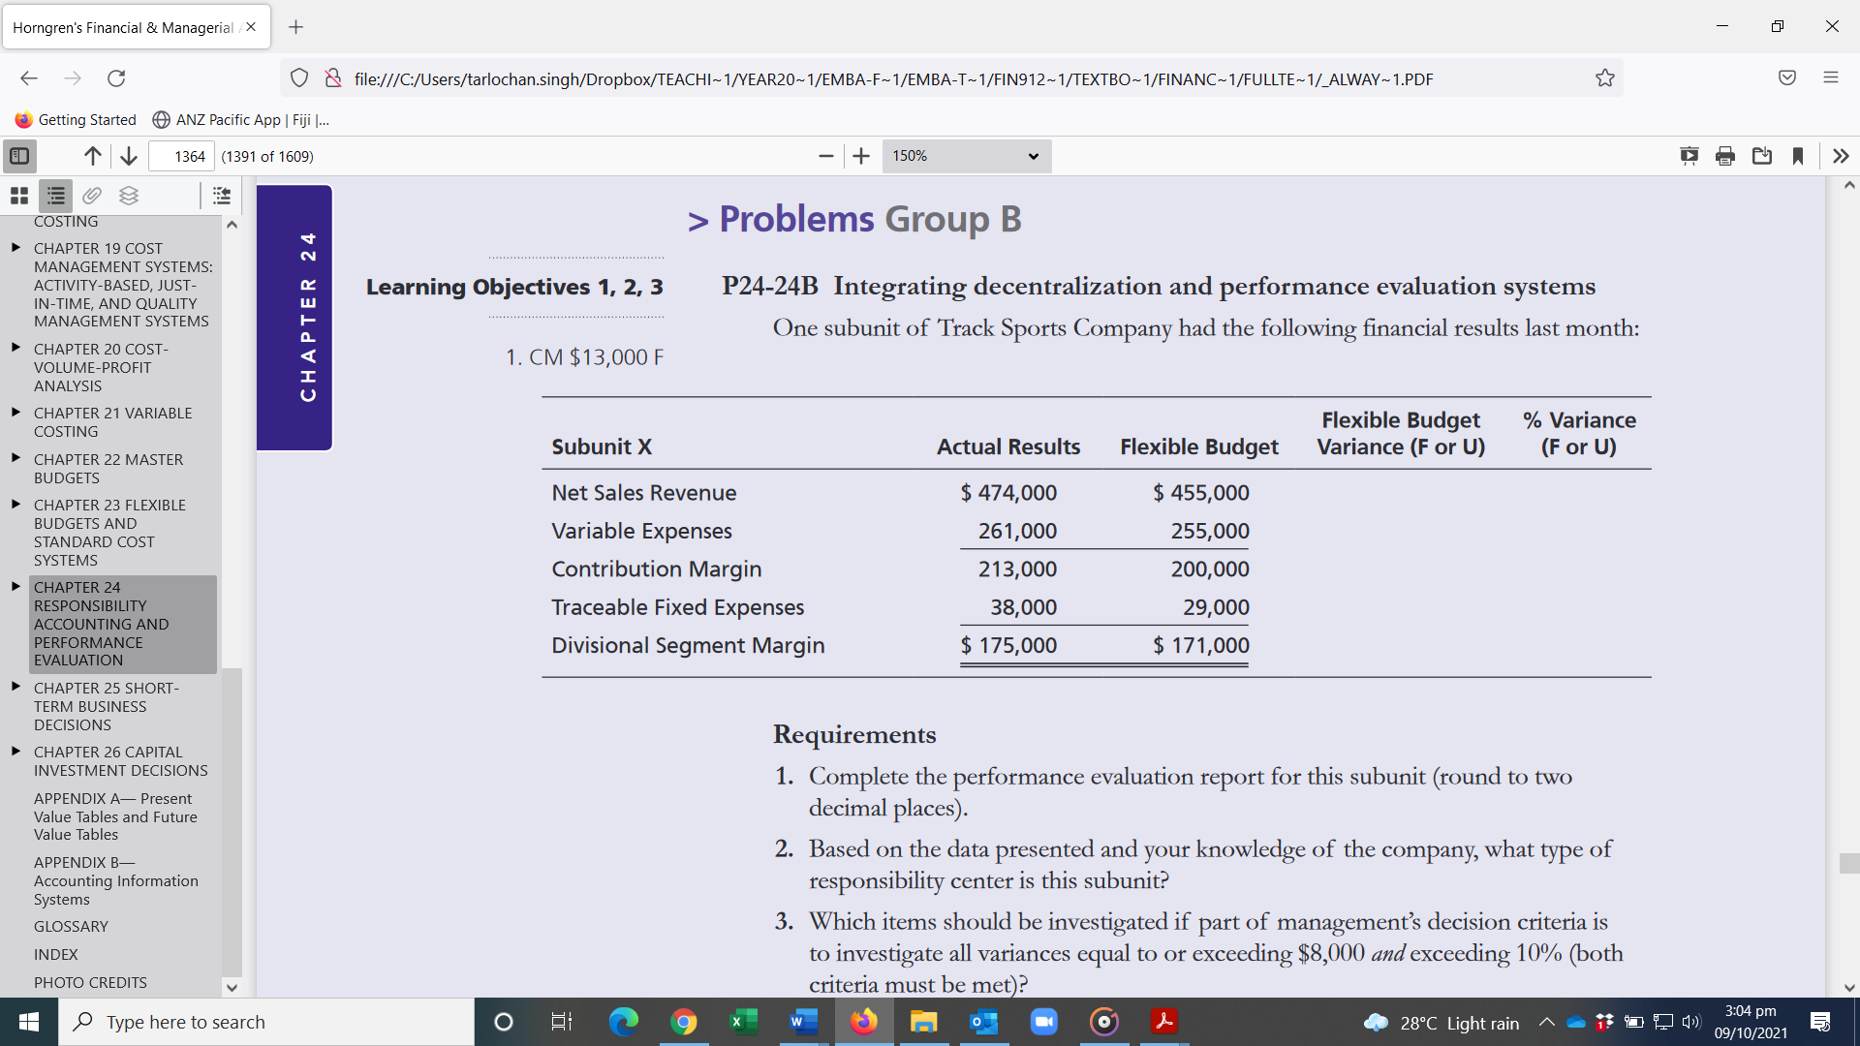
Requirements
1. Complete the performance evaluation report for this subunit (round to two decimal places).
2. Based on the data presented and your knowledge of the company, what type of
responsibility center is this subunit?
3. Which items should be investigated if part of management’s decision criteria is
to investigate all variances equal to or exceeding $8,000 and exceeding 10% (both criteria must be met)?
4. Should only unfavorable variances be investigated? Explain.
5. Is it possible that the variances are due to a higher-than-expected sales volume?
Explain.
6. Will management place equal weight on each of the variances exceeding $8,000?
Explain.
7. Which balanced scorecard perspective is being addressed through this performance report? In your opinion, is this performance report a lead or a lag
indicator? Explain.
8. List one key performance indicator for the three other balanced scorecard perspectives. Make sure to indicate which perspective is being addressed by the indicators you list.

